Problem:

* Too many false alarms (2FA)
* 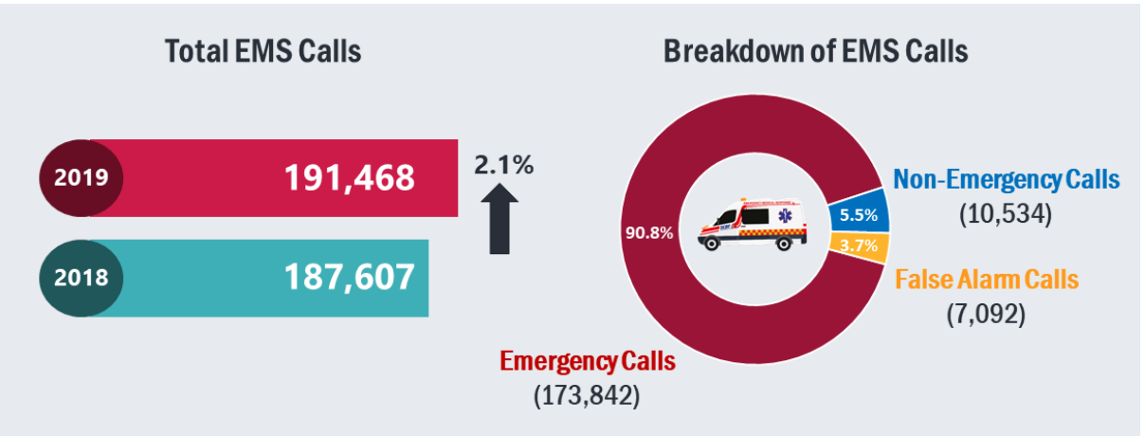

Problems with myresponder:

* myResponder App - Good! But needs some improvements
* Slow: Need to download an app
* Slow: Need to register an account
* Prone to crashes and   
  compatibility issues
* Gps prone to issues

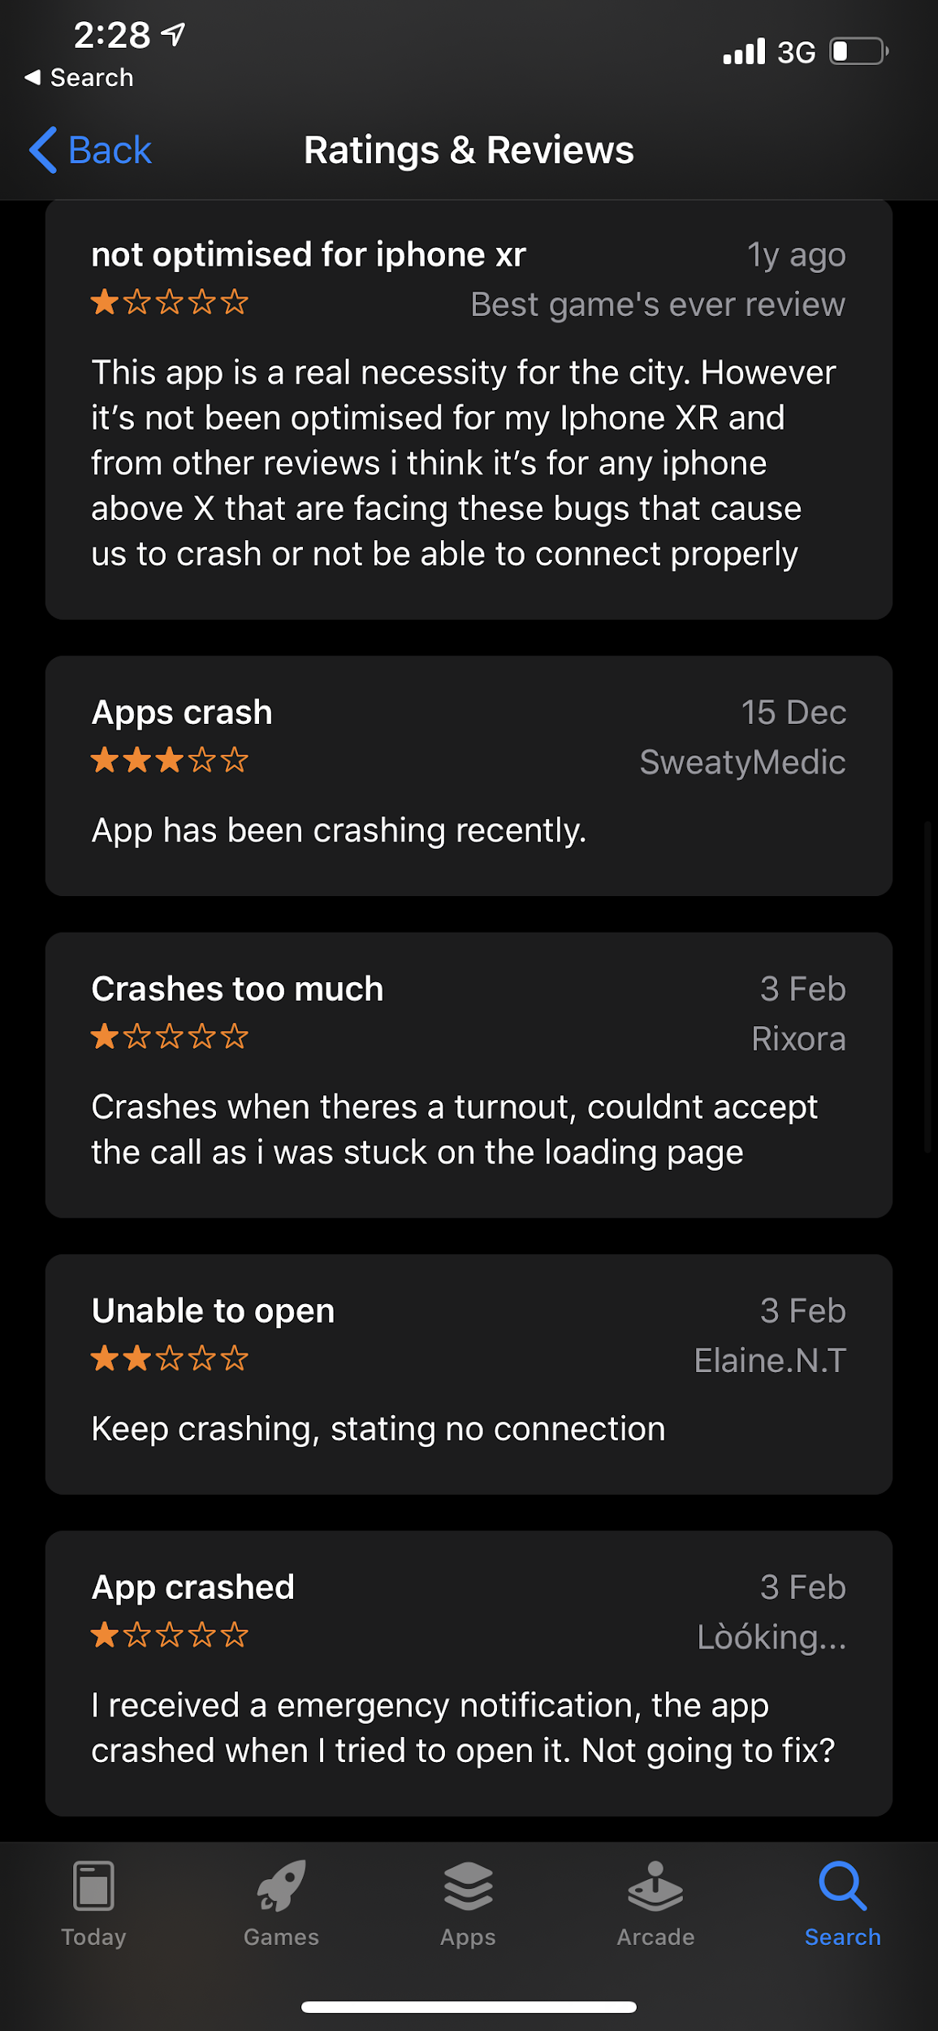 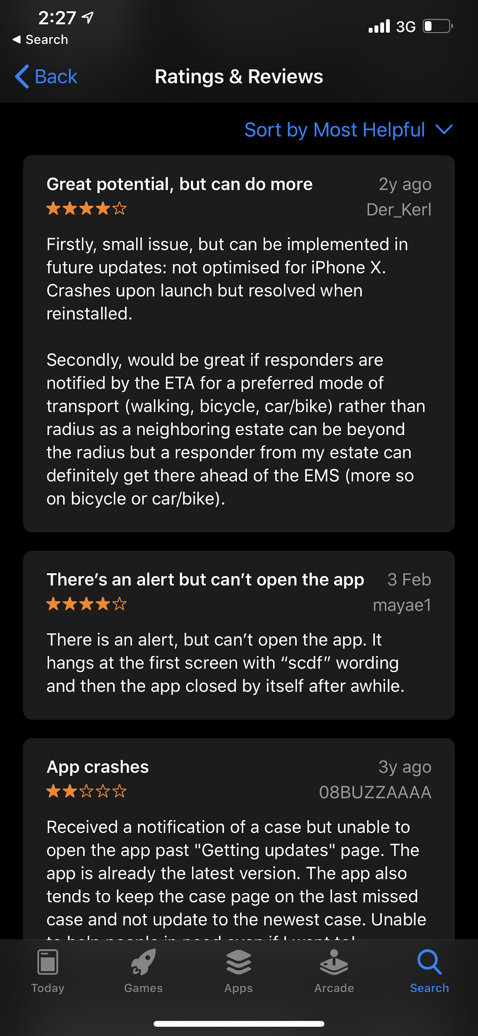 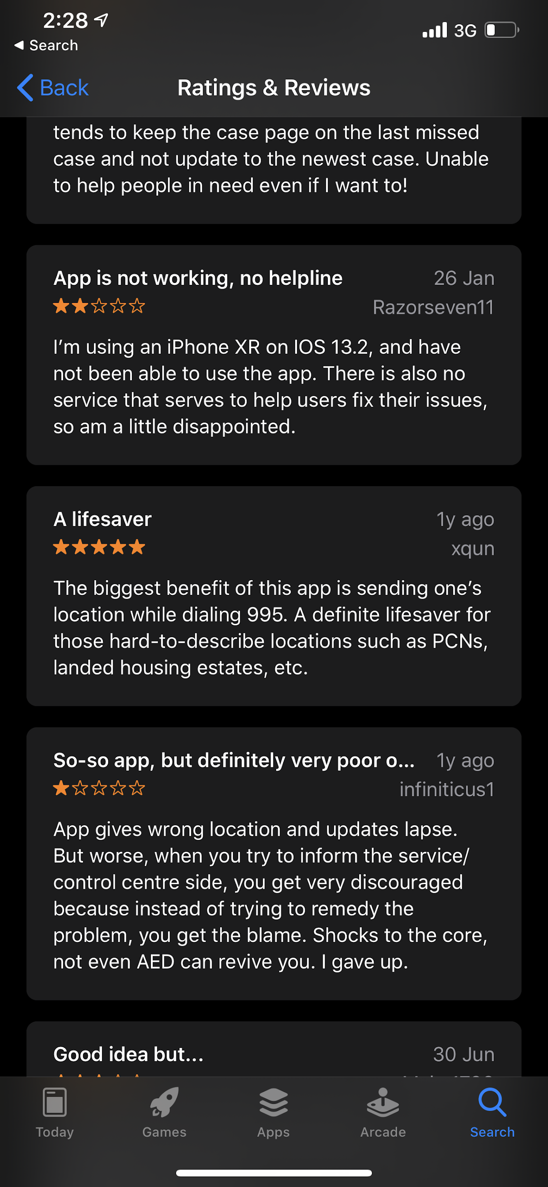

We can learn from:

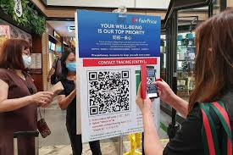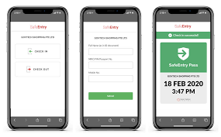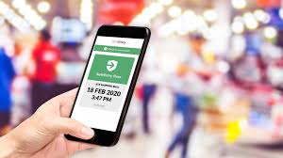

Spoof Proof

* Facial Recognition of the reporter (doing various pose to prove is real)
* Phone Number
* IP Address4
* Phone Physical Address
* Name
* NRIC

Creation

Volunteer/ SCDF will generate customised QR code at household with all information such as

* BloodType
* Name
* Nric
* Date Of Birth
* Allergies
* Medication (current)
* House address
* Medical History
* Gender
* Contact Number

App Flow:

1st

Scan QR Code at Resident’s House: (Main Focus)

-Verify the identity of the reporter and submit

-Pain Point (multiple people)

2nd

Scan QR at the void deck (Do If Got Time)

-Verify the identity of the reporter

-NRIC / Unit Number / Phone Number and Submit of Victim

Possible ( talk only , do if possible)

* Identify area of risk based on age population

3rd

Interface For SCDF

Future: (Not implementing , talk only)

* Different pose for image recognition
* Identify severity based on description (give priority?)
* Offer instructions with given conditions
* Contact local responder app users
* Update information without changing QR Code (like change of residence)